**CALL FOR PAPERS**

Special Session on ‘XXX’ **(Please add here the Title of the special session)**

**2025 13th International Conference on Information Management and Engineering**

**Conference Website:** [**https://icime.org/**](https://icime.org/)

**Okinawa, Japan | September 24-26, 2025**

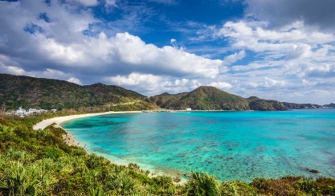 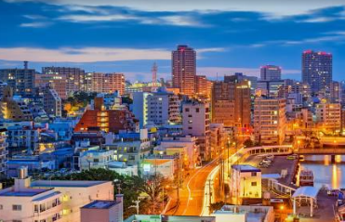

**Conference Venue: University of the Ryukyus-Faculty of Engineering**

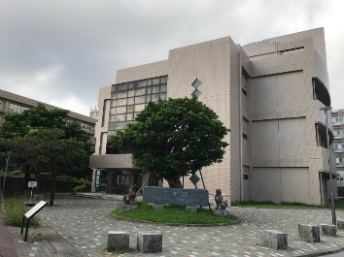

**ORGANIZED AND CHAIRED by**

Organizer 1 name and affiliation

Email address

Organizer 2 name and affiliation

Email address

**SPECIAL SESSION DESCRIPTION** (no more than 150 words)

Please add a short description of the topic

**TOPICS COVERED** (no more than 5)

* Topic 1
* Topic 2
* Topic 3
* Topic 4
* Topic 5

**Schedule:**

Deadline for submission of the paper (s) to the Electronic Submission System by selecting the desired special session – April 20, 2025

Co-sponsored by:

 

Supported by:

       

Published by:



Indexed by:  
 